Concept used for floating the Keithleys.

By Dave; Assistance by Patrick and Dr. Harris

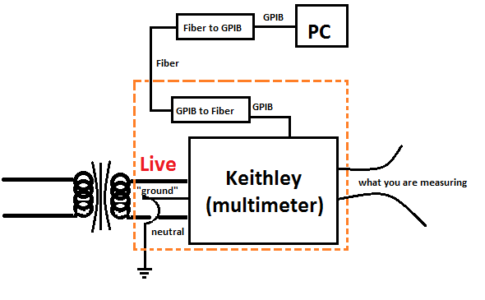

What we would do is float the ground of the Keithley power supply as well as floating the Keithley local ground box. The Keithleys are rated for floating their circuitry (normally just the local ground) up to a 500 Volt potential difference. The beam line sits at -400 Volts, which means the ground plane for the faraday cup is 400 volts. Thus, the instrument that is measuring with the Faraday cup needs to be floated to the Faraday cup voltage. (Probably need to look at ***Design, Construction, and Characterization of a low energy alkali ion source by Barbara Rachel Litt***…for more details.)

**Materials needed for floating Keithleys**:

-insulation columns, PVC pipe, PVC insulation (for outside pipe), Plexiglas screen (3 mm thick), GPIB to Fiber converter, and Fiber to GPIB converter.

-insulator to insulate the high voltage lines,

- Insulator to keep high voltage Keithleys from the grounded plane/frame,

- 3 mm Plexiglas screen, that will be used to screen people from touching the Keithley

- We will use PVC pipe to keep the high voltage cords together, wiring under control, and wiring isolated from ground. This PVC pipe is coupled with PVC insulation on the outside so that anything that touches the PVC, aside from high voltage cords, does not get affected by the high voltage.

--only problem with PVC pipe instead of aluminum is that you cannot ground the pipe. However, since we are not looking at grounding it anyways this works and it is also cheaper than an aluminum track.

-A23S: Alkaline super P+US battery – to replace old battery in doorbell. This way people can use the doorbell to notify when they are going to enter the room. (So researchers taking data do not get shocked from accidentally touching the ungrounded areas when someone enters into the room.)

____________________________________________________________-

Materials used for EBIT: HPIB to Fiber converters; J04-125: 4600 N insulator; about 8.25” insulation that is rated for 1000+ voltage. It also had ET M65 EWC –C090-120105 on the insulator.

___________________________________________________________________________________

Keithleys we want to float/fix:

|  |  |  |  |  |  |
| --- | --- | --- | --- | --- | --- |
| Name | Model | Serial #; Clemson Prop # | Nomenclature |  |  |
| Keithley | 6512 | 0627324; 201569 | Programmable Electrometer | | |
| Keithley | 617 | 342015; N/A | Programmable Electrometer | | |
| Keithley | 6485 | 0969458; N/A | Quasistatic CV meter | | |

Roll up of Keithley instruments

|  |  |  |  |  |  |
| --- | --- | --- | --- | --- | --- |
| Unserviceable at Tektronix as of February 26, 2019 | | | | | |
| Name | Model | Nomenclature | | | |
| Keithley | 6512 | Programmable Electrometer | | | |
| Keithley | 617 | Programmable Electrometer | | | |
| Keithley | 595 | Quasistatic CV meter | | | |
| Keithley | 705 | scanner | | | |
| Keithley | 220 | programmable current source | | | |
| Keithley | 195 | digital multimeter | | | |
| Keithley | 191 | digital multimeter | | | |
|  |  |  |  |  |  |
|  |  |  |  |  |  |
| Can be serviced at Tektronix as of February 26, 2019 | | | | | |
| Name | Model | Nomenclature | | | |
| Keithley | 2400 | source meter | | | |
| Keithley | 2000 | multimeter | | | |
| Keithley | 6485 | Picoammeter ($780.00) | | | |
|  |  |  |  |  |  |
| To find out if Keithley is serviceable or not contact tech support via: 1-800-833-9200 | | | | | |
|  |  |  |  |  |  |
| Repair service phone number: 503-627-2445 | | | | |  |
| Repair service also includes a calibration | | | | |  |
|  |  |  |  |  |  |
|  |  |  |  |  |  |
| Tech support: 1-888-534-8453 | | | | |  |
| Tech support email: ki-support-apps@keithley.com | | | | |  |
|  |  |  |  |  |  |
| Custom-Cal: company that might be able to fix electronics. If you pay for shipping, they will look at it. Make a quote. Then you can go through with service for fix; or they return it instead (free of charge (aside from shipment.)) | | | | | |
| https://www.custom-cal.com/ | | | | | |
| contact info: dvangorden@custom-cal.com | | | | | |
| phone: 609-530-9000 | | | | | |